**SCD TYPE-0**

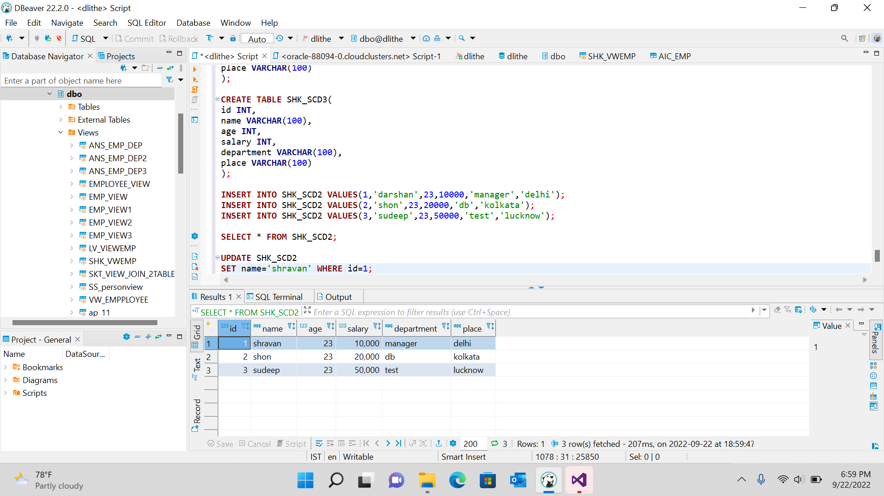

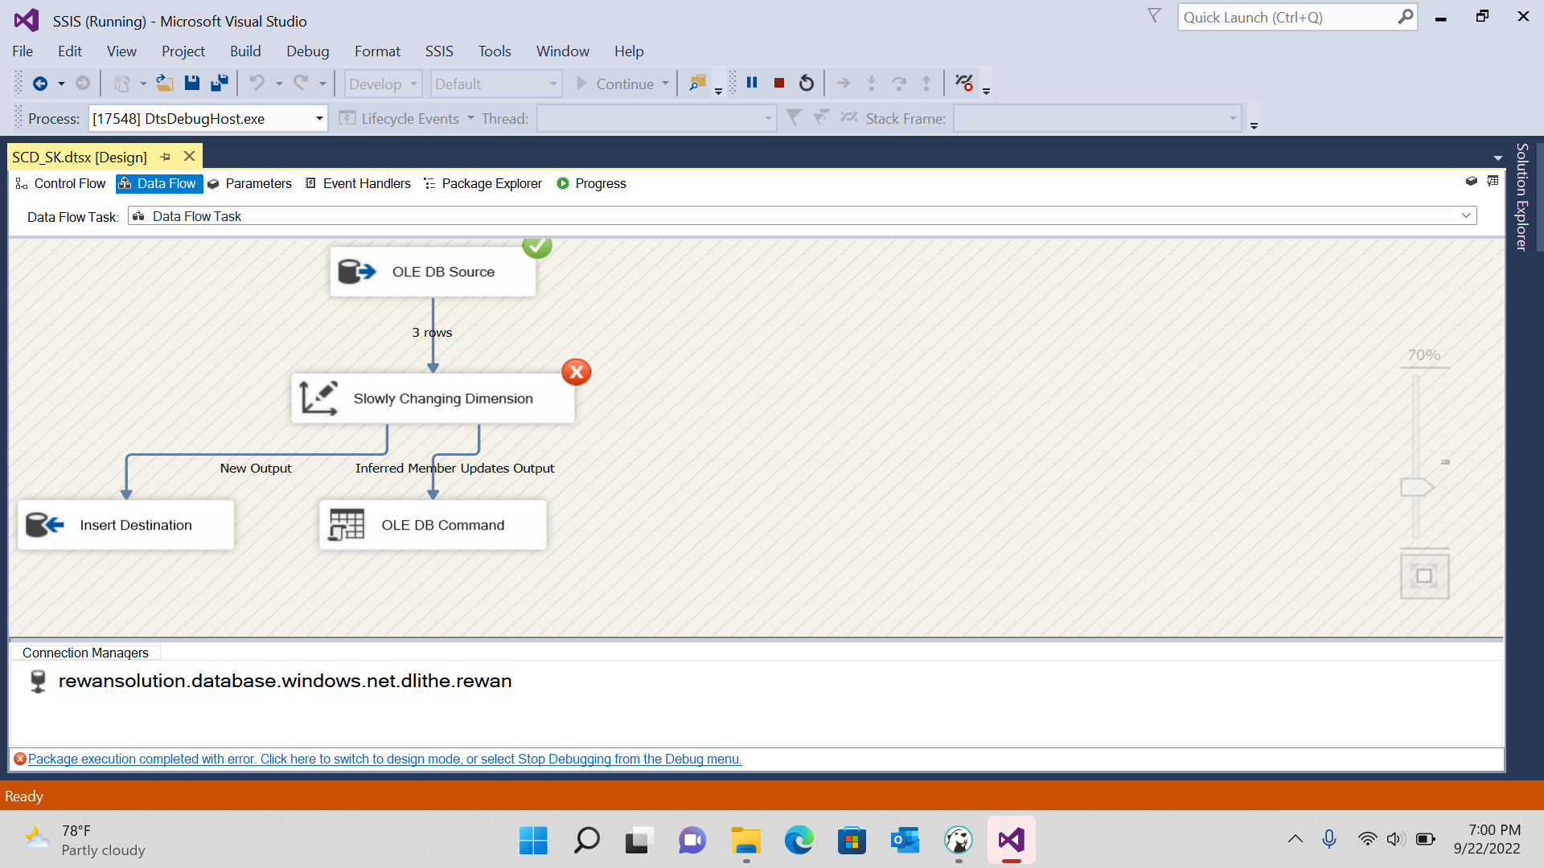

**SCD Type-1**

**SCD Type-2**

